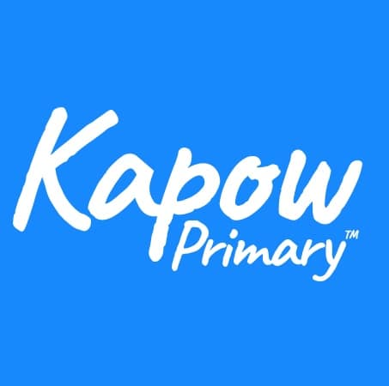
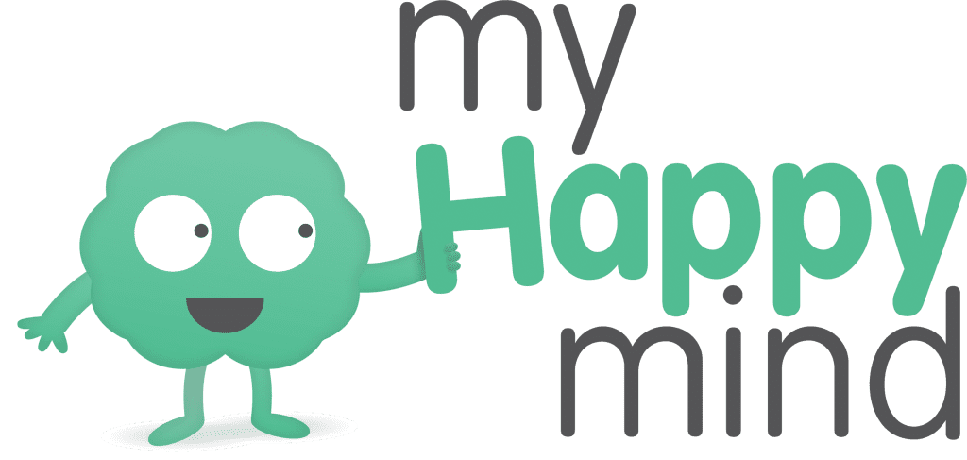
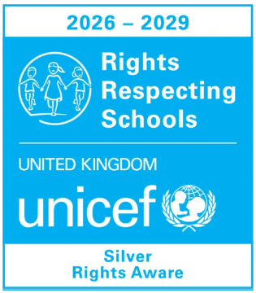
Intent
At Burton Green Primary School, we aim to equip children with the knowledge, understanding and personal skills they need to lead healthy, safe and fulfilling lives. We want our pupils to develop a strong understanding of their physical and mental wellbeing, build resilience, manage life's challenges and make informed decisions that positively influence their current and future lives.
Our PSHE and RSE curriculum is delivered through Kapow's progressive two-year rolling programme, ensuring full coverage of statutory requirements and key learning for all pupils. Through discussion, practical activities and real-life contexts, children develop the knowledge and skills needed to build positive relationships, understand themselves and others, and become active, responsible members of society.
Alongside Kapow, we use My Happy Mind on a three-year cycle to further strengthen children's mental health, emotional wellbeing and self-regulation. Having seen the positive impact, the programme has on children's confidence, resilience and self-esteem, we are committed to revisiting and embedding these essential skills across the school.
Through our PSHE and RSE curriculum, we aim to develop reflective, resilient and compassionate learners who can think critically, respect diversity, develop a strong sense of identity and belonging, and confidently navigate the opportunities and challenges of modern life.

We will:
- Provide at least one hour of dedicated PSHE/RSE learning each week.
- Deliver a comprehensive PSHE curriculum through Kapow's two-year rolling scheme.
- Use My Happy Mind to promote wellbeing, resilience, self-esteem and emotional regulation.
- Equip pupils with the knowledge and skills to lead confident, healthy and independent lives.
- Encourage pupils to recognise their strengths, build positive relationships and take responsibility for their actions.
- Develop children's understanding of rights, responsibilities, diversity and respect for others.
- Foster curiosity, critical thinking and informed decision-making to prepare pupils for life in modern Britain.
Implementation
Curriculum Delivery and Wider Opportunities
- Children receive explicit teaching on Protective Behaviours and Keeping Safe at the start of each academic year, with key messages revisited regularly throughout the year.
- PSHE and RSE are delivered via a two-year rolling programme (Kapow).
- As a Rights Respecting School, dedicated time is planned each half term to deepen children's understanding of their rights and responsibilities. This helps pupils develop their voice, confidence and self-advocacy skills.
- Themed days and national awareness events provide opportunities to explore important topics in greater depth, such as Children's Mental Health Week, Anti-Bullying Week and Safer Internet Day.
- Visitors enrich the curriculum by providing real-life experiences and discussions linked to PSHE themes. These may include financial education providers, firefighters, police officers, health professionals etc.
- Through lessons and wider opportunities, children are encouraged to explore their thoughts, feelings and experiences in a safe environment.
- Children are provided with opportunities to develop leadership, responsibility and citizenship.
Assessment
- Assessment is ongoing and embedded within lessons through discussion, observation and pupil responses.
- Knowledge and skills progression is monitored across year groups to ensure children build upon prior learning and can apply key concepts confidently.
- Evidence of learning is gathered through recorded work, pupil voice and practical activities.
Monitoring
- Regular staff feedback is used to evaluate curriculum effectiveness and identify professional development needs.
- Learning walks, lesson drop-ins and pupil voice activities are used to monitor the quality and impact.
- PSHE books and other evidence of learning are reviewed to assess progression in knowledge, skills and understanding.
- Monitoring of wider personal development opportunities helps ensure children can apply their learning confidently.
Impact
- Children develop the knowledge, skills and attitudes needed to thrive, with confidence in discussing wellbeing, relationships, health, safety, rights and responsibilities.
- Children demonstrate resilience, emotional literacy and self-regulation, and feel safe, valued and confident.
- Through Rights Respecting and Protective Behaviours approaches, children develop self-advocacy skills, understand their rights and can identify trusted adults who can support them.
- Children leave Burton Green as respectful, responsible and inclusive citizens who are prepared for the next stage of their education and life.
Teacher CPD and Monitoring
- The subject leader provides training, support and guidance to ensure high-quality PSHE and RSE teaching.
- Staff engage in professional development and share effective practice.
- Monitoring to inform future CPD and development.
Family and Community Engagement
- Parents are involved through Protective Behaviours, Rights Respecting work and other PSHE themes.
- Assemblies, performances and celebration events provide chance to share with families and the wider community.
- Visitors enrich learning and strengthen links between school, home and the community.
Current Priorities / Next Steps
- Further strengthen Online Safety across the curriculum.
- Review curriculum coverage to ensure consistency and progression across the two-year rolling programme.
- Continue to embed children's rights, pupil voice and self-advocacy across school life.
- Monitor and evaluate the impact of the revised PSHE curriculum.

