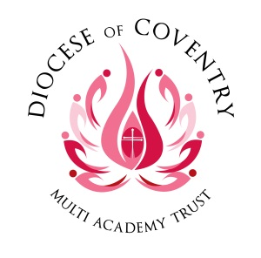
Burton Green Academy
Spirituality Policy


Document date: January 2025

Together, pursuing life in all its fullness

CONTENTS

- Our Multi Academy Trust Vision

- Academy Vision
- Legal Framework: Links to OFSTED and SIAMS expectations

- School Statement on Spirituality

- Aims

- Organisation

- Spirituality in Collective Worship
- Spirituality in Religious Education

- Spirituality within the Curriculum

- Spirituality within the Ethos and Daily Life of the School
- Spirituality within the Ethos and Daily Life of the School

- Recording, Monitoring and Evaluation

- Roles and Responsibilities

- Staff Development and Training

- Additional Support Material

Template  Version | Date | Author | Changes
V1 | January 2025 | Donna East | Initial Issue.  Based on Debbie Hulme’s Model Policy for Spirituality Template for the Diocese of Gloucester.

Template Review frequency | 3 years
Template Review date | January 2028
Template Ratified by | AGC
Date of ratification
Lead/owner | Head of Education
Target audience | Parents and Public
Document reference

The electronic version is the definitive version of this document.

- Our Multi Academy Trust vision
The Core Mission of the Diocese of Coventry Multi Academy Trust is to build a better future for all within our Academies who in turn will positively impact their communities.

‘Together, pursuing ‘life in all its fullness’ (based on John 10, 10)

- Academy vision
Within a Christian framework at Burton Green C of E Academy we aim to challenge and support all pupils to enable them to develop their talents and achieve their potential. All individuals are valued irrespective of ability, race, gender, culture or faith.
We aspire to provide excellent teaching and stimulating learning experiences across a broad and balanced curriculum, within a happy, caring, inclusive and safe environment.
We aim to enable each child to develop the personal and social skills necessary for them to become independent, responsible, active participants in their community through partnerships with home, our parish churches, local neighbourhoods and the wider community.
Our dedication to supporting the spiritual growth of both our pupils and staff is deeply rooted in our Christian vision:

‘Live Life in all its Fullness’

As a Church of England school, we recognise the importance of providing a rich and diverse spiritual environment that caters to the needs of our multicultural community.

- Legal Framework: Links to OFSTED and SIAMS expectations

The OFSTED School Inspection Handbook, November 2019 No. 190017, page 59 & 60, states:
Inspectors will evaluate the effectiveness of the school’s provision for pupils’ spiritual, moral, social and cultural education. This is a broad concept that can be seen across the school’s activities but draws together many of the areas covered by the personal development judgement.

Provision for the spiritual development of pupils includes developing their:
- ability to be reflective about their own beliefs (religious or otherwise) and perspective on life
- knowledge of, and respect for, different people’s faiths, feelings and values
- sense of enjoyment and fascination in learning about themselves, others and the world around them
- use of imagination and creativity in their learning
- willingness to reflect on their experiences.

The SIAMS Evaluation Schedule for Schools and Inspectors, April 2018, includes the question:
- How well does the school support all pupils in their spiritual development, enabling all pupils to flourish? (Strand 2)

- School Statement on Spirituality

To talk about spirituality is, essentially, to talk about something which is beyond words. To make conversations about spirituality more accessible to every member of our school community, Burton Green Academy has chosen to follow ideas developed by the Education Department at the Diocese of Gloucester.
This language of spirituality begins from a Christian understanding that everyone is a valued creation, individually and uniquely made by God, like pots made by a potter (Isaiah 64:8). Yet, in life things happen that impact on the physical ‘pot’ of life and create cracks that provide a glimpse of something ‘beyond’ the tangible. Christians would view this as an opportunity to relate to the Divine Creator God.
Cracks may be caused when something so good and breath-taking happens that the pot expands and cracks – the wows of life.
Cracks may happen when something challenging happens and threatens the comfort of everyday – the ows of life.
Cracks can also happen in the stillness and ordinariness of everyday – the nows of life, when a moment of stillness, a pause or prayer creates a crack in the normal, physical everyday.
In these special moments there is a spiritual opportunity. Kintsugi, the Japanese art of mending broken ceramics with golden joinery or glue, creates something that has been broken into something even more beautiful. Using this metaphor, the wows, ows and nows of life offer the possibility of cracks that are filled with gold and make the pot even more beautiful. The gold in the cracks reflect a little of the wonder of spirituality.
Burton Green Academy uses this language and the concepts of wows, ows and nows. These are used to explore relationships with:
- ourselves
- others
- the wider natural world and beyond
- and offering the invitation to relate to God

- Aims

School’s Christian Vision:
Live Life in All It’s Fullness

Our vision is rooted in three guiding principles:

- Value yourself - we encourage children to develop self-belief, resilience, and a positive sense of identity. We help them to recognise their strengths, take pride in their achievements, and care for their own well-being.
- Value each other – we promote kindness, respect, and empathy, celebrating the uniqueness of every individual. Belonging and support are at the heart of our school, making sure every member of our community feels valued and cared for.
- Value the world we live in - we inspire children to be responsible citizens who care for the environment, celebrate diversity, and contribute positively to society. By encouraging curiosity and responsibility, we prepare them to make a difference in our ever-changing world.

- Organisation

The spiritual growth of pupils is not only dependent on learning in RE, opportunities for enhancing the spiritual wellbeing of learners are developed in every aspect of our school life.
We support the whole school community to share this responsibility and to develop the shared language of spirituality. Opportunities are available for all to develop spiritually in our supportive and nurturing school inspired by our vision and lived out through our Christian values.
We have identified specific areas which contribute to the spiritual growth of pupils:
collective worship, the whole curriculum, including RE and the general ethos of the school within daily life.

- Spirituality in Collective Worship

Collective Worship is the beating heart of Burton Green Academy. It provides the opportunity for our school community to share experiences, ideas and understanding. It is the context in which the language of spirituality, which we use as a school, is regularly and explicitly shared.
Collective Worship provides the opportunity for pupils to become aware of the importance of reflection and how our positive and negative experiences can be formative. It also provides a real sense of being present (now moments) which are often linked to invitations to pray.
Through daily Collective Worship, pupils are offered a space and a place for hearing the Christian story. They are offered an understanding of worship by being invited to participate in, or observe, Christian spiritual practices such as: prayer, reading and reflection on the Bible and liturgy and are introduced to different musical traditions.
Opportunities to reflect on the wows of life such as beauty and joy of the world are given, as well as time to reflect and empathise with the ow moments of disappointment or pain. Pupils are given time to consider their responsibilities to others and to grow in love and service. Time is given for celebration, both for the accomplishments of school members and to mark seasonal Christian festivals and celebrations in the calendars of other faiths. In this way pupils are offered time to be able to contemplate and develop spiritually. Collective Worship in Burton Green Academy is invitational, inspirational, and inclusive.

- Spirituality in Religious Education

The Church of England’s Statement of Entitlement outlines the aims and expectations for Religious Education in Church of England Schools and guides this school’s approach to RE and spirituality.
Learning activities in RE provide for the needs of all pupils, offering a safe space to explore their own religious, spiritual and/or philosophical ways of seeing, living and thinking, believing and belonging. They provide opportunities to engage in meaningful and informed dialogue with those of all religions and worldviews, linking these to pupils’ ideas of spirituality and the language of wows, ows and nows where appropriate.
For further details, please refer to Burton Green Academy’s Religious Education Policy and The Church of England’s Statement of Entitlement.

- Spirituality within the Curriculum

Drawing on the language of wows, ows and nows, conversations around spirituality will be included in classroom teaching when appropriate from Reception to Year 6.

Maths
Points to consider:
- The wonder of number patterns
- What cannot be measured? For example, love
- What cannot be accurately counted? For example, the difference an act of kindness makes.

Reading
Points to consider:
- How do you frame questions around a text? For example: What inspired you in this text? How did a character cope with a challenge in life? How did the actions of a character surprise you? How do you think you would have responded to that wow or ow moment? What do you think makes these words so powerful/beautiful/painful?

Writing
Points to consider:
- If pupils are invited to write about things that have profound meaning to them, how is writing valued? How can it be recognised as having value, rather than simply be reduced to an evaluation of SPAG?

DT
Points to consider:
• What motivates designers and their decisions? For example, is it a desire to make money or a desire to help and make improvements to daily life for everyone?

Music
Points to consider:
- What style of music ‘invites you to explore the mystery that dances within your soul’ (K. Hall)?
- What styles of music have the opposite effect?
- How does music encourage creativity, delight, and curiosity?

MFL
Points to consider:
- What motivates language learning? For example, buying an ice cream on holiday or welcoming and comforting a stranger in our country?
- What does it feel like to genuinely communicate with someone in a new language?

Geography
Points to consider:
- The wow of physical geography.
- The ow of discovering different physical regions do not provide the same opportunities.
- What options/opportunities are there to respond and take responsibility in a challenging world?

History
Points to consider:
- Which stories tell historical wows?
- Which stories tell historical ows?
- What lessons for future decisions and choices do they provide?

PE
Points to consider:
- How do you celebrate a new skill? How does it feel to be proud of your whole self?
- What does it feel like to be completely focused on a task or challenge?
- How do you recognise the delight in movement, connectedness, and creativity?
- Encourage the awareness of one’s own strength and limitations.
- Recognise/celebrate equality, freedom, respect and trust.

Science
Points to consider:
- Delight in discovering how things work.
- Opportunities to linger longer on the wonder!
- What questions cannot be answered by science?

Art
Points to consider:
- How does art invite you to explore the mystery that dances within your soul?
- What are the wows and ows in the stories behind the artists you study?
- How do you celebrate and respect different responses to art?

PSHE & RSE
Points to consider:
- As you explore topics such as relationships, feelings & attitudes, keeping safe and ‘your body’ where are the natural links with the wows, ows and nows?
- How can the honesty and sensitivity needed to explore these topics gently reflect the language of spirituality already used throughout the school?

All Subjects
Points to consider:
- How do you celebrate the achievement and break-through wows of success?
- How do you support the ows of difficulty and frustrations?
- How do you maximise the everyday moment of concentration and being in the present, creating a sense of calm and completeness?

- Spirituality within the Ethos and Daily Life of the School

In Burton Green Academy we view spiritual growth as becoming more and more aware of one’s natural, innate spirituality. These opportunities happen throughout each and every day as children deal with delight, disappointment and the chance to be present with themselves.
For this reason, every member of the school community, including MDSA and administrative staff are familiar with the school’s shared language of spirituality and will respond to pupils appropriately.
Throughout the daily life of the school, including lunch times and playtimes, pupils know that their references to wows, ows and nows will be heard and taken seriously. They will be encouraged to reflect on these experiences and be comfortable about talking about the golden glue of spirituality.

- Recording, Monitoring and Evaluation

The AGC review the policy every three years in partnership with Senior/ Middle Leaders and consider any views expressed by parents, children and staff in order to make any changes or recommendations. Recommendations are fed back to the full governing body and are then actioned as appropriate.
Governors ensure that this policy is fully implemented and that practice is consistent with the school’s Christian vision, in line with the school’s monitoring policy and schedule for governors.

- Roles and Responsibilities

Recognising there are opportunities for enhancing the spiritual well-being of learners in every aspect of our school life, every member of our staff team is committed to support this spiritual growth wherever appropriate.
Donna East is responsible for supporting and leading spiritual development in our school, including monitoring opportunities for spiritual growth in collective worship, the whole curriculum (including RE) and the general ethos of the school within daily life,
This role also includes:
- Ensuring personal knowledge and expertise are kept up-to-date by participating in CPD and shared good practice
- Providing and sourcing in-service training for staff as necessary
- Ensuring all staff are familiar with the shared language of spirituality
- Acquiring and organising appropriate resources, managing a budget when necessary
- Monitoring the opportunities for spiritual growth through regular observations and learning walks in both formal and informal contexts, discussions with colleagues and pupil voice
- Contributing to the SIAMS self-evaluation process particularly around Strand 2

- Staff Development and Training

We ensure that all staff, including support staff, receive appropriate training and opportunities for professional development, both as individuals and as groups or teams. ECTs and staff who are new to Burton Green Academy will receive training and support from the staff member identified as leading on spirituality.

This policy is shared on the school’s website and is part of the induction pack for new staff and new governors.
This policy is reviewed every 3 years, or more frequently, as required.

- Additional Support Material
Useful questions for the school to consider:
- How does the school’s Christian vision provide opportunities to meet the spiritual needs of learners?
- How does an awareness of spirituality permeate school life?
- What is the impact of this for the learner (and staff and the wider community)?
- How are staff inducted and supported so that they have a shared understanding of spirituality and spiritual development?

Prayer used by the school:
Mysterious God,
Most of the time we can explain what happens in the world by science
But sometimes we may see a glimpse of something beyond:
The joy of making a new friend,
The excitement of being able to do something today which we couldn’t do yesterday, The delight of warm sun on our faces or splashing in cold puddles.
In these wow moments, when we’re aware of something beyond,
Help us to be open to the idea of you, God.

Comforting God,
Most of the time we feel safe and secure
But sometimes life can be difficult and painful and we long for something beyond:
Someone who understands what it’s like to be alone,
Or let down by friends,
Or feel like they have nowhere to call home.
In these ow moments, help us to be open to something beyond
And brave enough to reach out and pray.

Constant God,
Most of the time we are busy running or learning or playing,
But sometimes it’s good simply to be, help us then to glimpse something beyond the everyday:
When we are still,
When we are present to ourselves,
When there is nothing to distract us.
In these now moments, help us to be open your possibility God
And help us to pray.
Amen

Spirituality Conversation Starters
Learning
from

w
ow
Experiences

What I’ve learnt from this
wonderful

w
ow
experience…

I think this is amazing because…

The biggest day in my life was…

A person who I think is really good is…

What matters most to me is…

I am most thankful for…

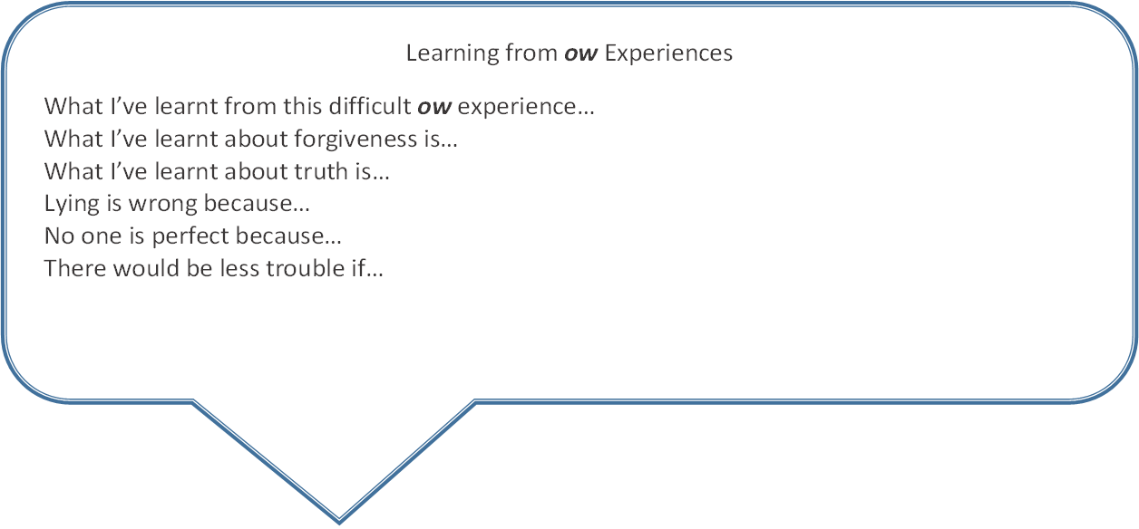

Learning
from

n
ow
Experiences

What I’ve learnt from this
no
w
experience…

What I’ve learnt
about love is…

The world would be a better place if…

I can find peace by…

I think God is like…

One thing I wonder about
God is…

I felt God was near me when…

Silence makes you feel…

