

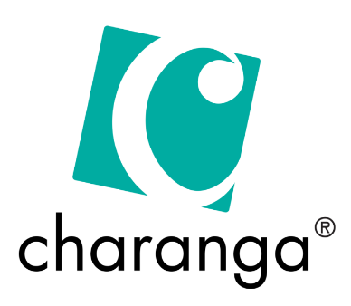
We use Charanga’s step-by-step program to help children build their musical skills. The resources include lesson plans, songs, and activities, students explore music by singing, listening, playing instruments, and making their own songs. The scheme covers a range of music styles, helping children get creative, confident, and excited about music.

Intent:
As a federation, we ensure that, all children have access to at least 45 minutes of music teaching a week, in addition to music shared and created through whole school and class worship. This is taught both as blocks (to enable topics to be covered in depth) and as weekly sessions.
- The coverage of music enables children to acquire an understanding of all relevant aspect of music.
- The Curriculum is split up into units of work from our ‘Charanga’ music program (2-year rolling programme to cover mixed age coverage)
- This program helps us to plan our lessons and gives us valuable resources to help with the teaching of Music

Implement:
Coverage through Music curriculum & extra-curricular:
- All children will have the opportunity to play instruments and compose music
- KS2 children have the opportunity to take individual and group instrument lessons - Warwickshire Music service
- Children’s confidence will be enhanced by taking part in annual/termly productions
- Children in KS2, can join the school choir, having the opportunity to perform at Young Voices/ I Sing Pop
- Year 6’s have the opportunity to put on performances for the local parish/community.
- Music lessons are planned and delivered using ‘Charanga’ (online Music resource).
- Teachers have an overview of which Music objectives they should be teaching each half-term showing progression through the year groups.
- Performances – EYFS/KS1 Nativity and Carols, Year 3/4 Easter Play, Year 6 End of year Performance
Assessment:
- Ongoing assessment within lessons
- Opportunity to assess pupil progress through performances.
- Pupil passports to highlight achievements throughout the Charanga lessons.
Monitoring:
- Audit of Instruments
- Staff CPD available
- Regular staff feedback

- Learning walk/drop-ins scheduled
- Pupil Voice
- Work scrutiny

Impact:
- Children can think and compose creatively and represent ideas through music.
- Children can use their voices expressively and perform / improvise with confidence in solo and ensemble contexts.
- Children can play musical instruments with increasing accuracy, fluency, control and expression.
- Use specialist vocabulary and understand musical notation.
- Appreciate different music from different traditions, genres, composers and periods of history.

Teacher CPD/ monitoring:
- Subject leader to provide CPD to increase staff confidence
- Team leader to attend training opportunities.
Community/ families:
- Musical performances at the end of term
- Families invited into assemblies
- Children performing in the community (Christmas).
- Extracurricular musical activities (music lessons, Young Voices)
- Children who take music lessons perform in front of school and parents - Assemblies
Key Priorities
- Liaise with Warwickshire Music Hub, for further CPD/events
- Develop a secure assessment system, using Charanga as a focus.
- Organise specialist teachers/companies to perform and teach the whole school for a day- eg: musical workshop.

