Music development plan summary:
Burton Green C of E Academy

Overview
Detail | Information
Academic year that this summary covers | 2025-2026
Date this summary was published | October 2025
Date this summary will be reviewed | July 2026
Name of the school music lead | Marianne Greig
Name of school leadership team member with responsibility for music (if different)
Name of local music hub | Warwickshire County Music Service
Name of other music education organisation(s) (if partnership in place)

This is a summary of how our school delivers music education to all our pupils across three areas – curriculum music, co-curricular provision and musical experiences – and what changes we are planning in future years. This information is to help pupils and parents or carers understand what our school offers and who we work with to support our pupils’ music education.

Part A: Curriculum music
At Burton Green C of E Academy music is taught for one hour each week in all classes. We use a scheme – Charanga.
The scheme is taught over two years in each class – these are referred to as A and B Years to ensure coverage of the whole scheme.
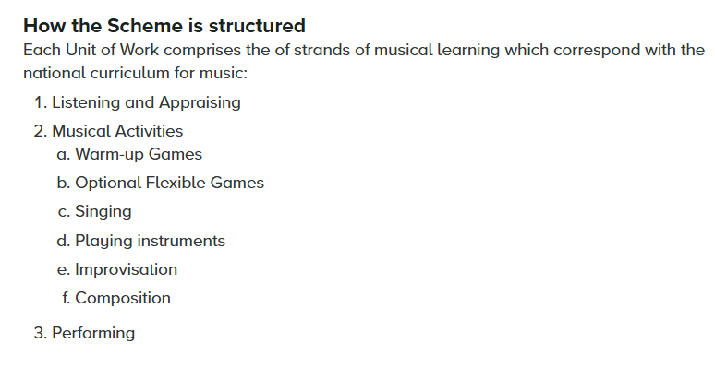 See the Long-Term Plan below
Ukulele’s and recorders are taught in whole class settings as part of the Charanga scheme. Other percussion instruments are used in addition to these.

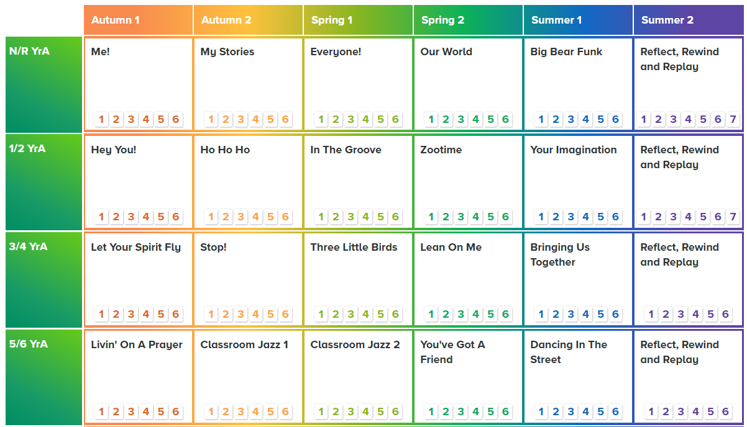
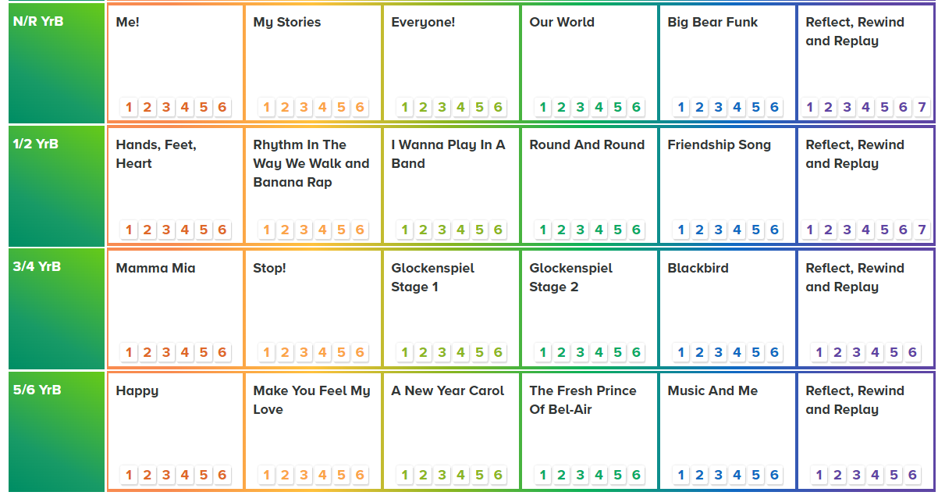

Part B: Co-curricular music
.Music tuition is available in school through the Warwickshire County Music Service. Guitar, Ukulele, Keyboard and Violin are our current offer. Lessons can be taught in small groups (Max 3) or individually.
Children taking these lessons can work towards qualifications and are able to take part in music assemblies showcasing their skills.
Instruments can be loaned from Warwickshire County Music Service free of charge.
Music lessons are chargeable, fees are set according to Warwickshire County Music Service charges. We aim to ensure equal access to the wider curricular opportunities for all children, and therefore we will consider subsidising fees accordingly.

Part C: Musical experiences
This is about all the other musical events and opportunities that we organise, such as singing in assembly, concerts and shows, and trips to professional concerts.
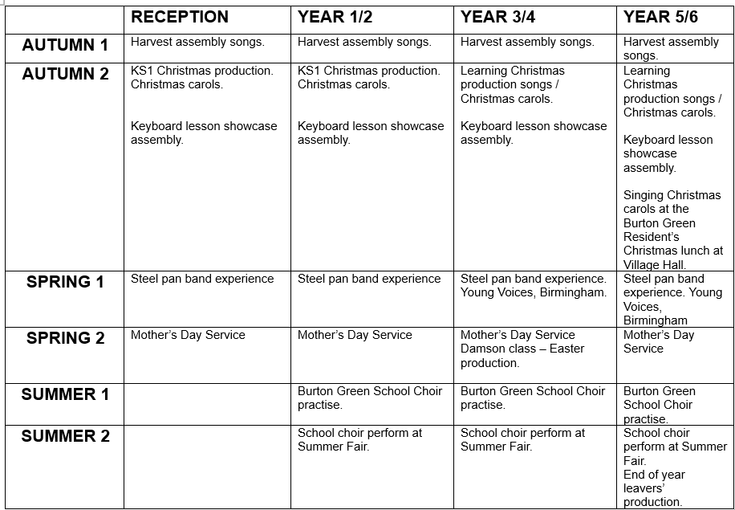

In the future
This is about what the school is planning for subsequent years.
Burton Green C of E Academy has taken part in Young Voices in Birmingham in past years – we are planning to revisit this experience and take part in 2026-27.
Once we have established our school choir (Summer 2026) we aim to take part in the Coventry Diocese Trust Christmas Choir event at Coventry Cathedral in December 2026.
In 2026-27 our music experience for the whole school will be a visiting rock band.

